Trinity HOPE Haitian Feeding Program
$7,000

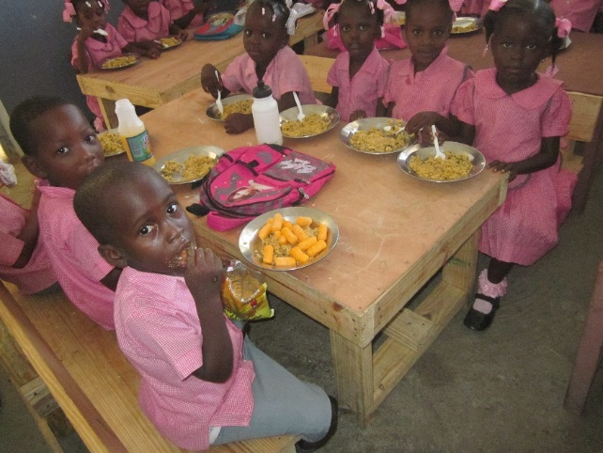
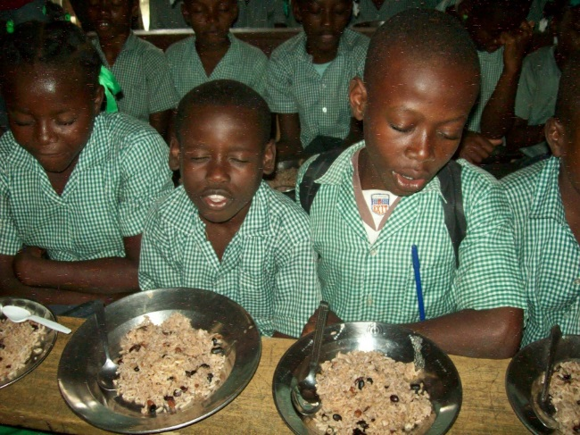

Trinity/HOPE provides a vital feeding program to the Christian school ministry in Haiti. In 1998, 42 children were being fed in one of our Lutheran schools. Today this ministry feeds over 15,000 children daily in 86 schools. The Word of God and the love of Christ is shared and taught in the classrooms. Voodooism, illiteracy, and poverty are being stopped.
Funds provided by the LWML Washington-Alaska grant will be assigned to one school enabling children to have more energy and be receptive to the teachings in their classes.

2022-2024 Biennium – LWML Washington-Alaska District

